|  |
| --- |
| South Africa Livelihood Zone Profile  59302 – Lowveld Open Access Irrigated Cropping (*ZALOI*) |
| Zone Description |

This livelihood zone is defined by the existence of irrigation projects that support crop farming. It comprises three areas:

Figure 1: Map of the livelihood zone

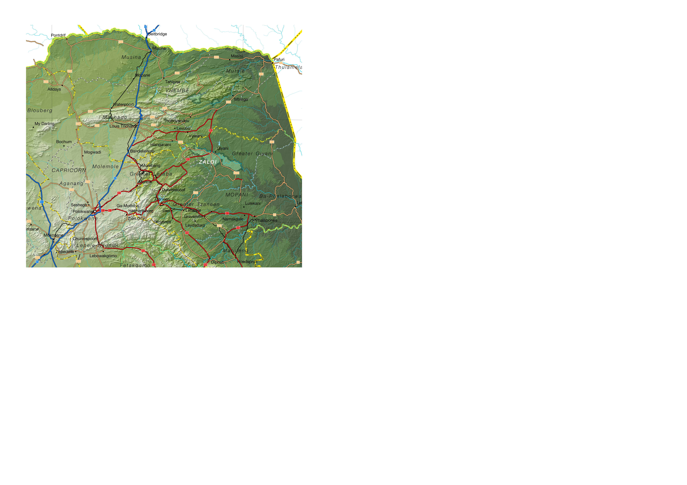Projection: Albers Equal Area with Standard Parallels at 22.67 S and 24.88 S, Longitude of Centre at 29.29 E.

Sources of data: Open Street Map, Highways (<http://wiki.openstreetmap.org/wiki/Planet.osm>) for the road lines, Shuttle Radar Topography Mission (SRTM) 3 version 2.1 (<http://www2.jpl.nasa.gov/srtm/>) for the elevation and relief shading and Agricultural Geo-referenced Information System (AGIS) (<http://www.agis.agric.za/agisweb/agis.html>) for place names, boundaries and rivers.

* 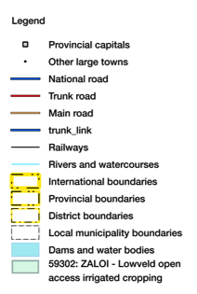The largest, along the southern bank of the Klein (Little) Letaba River in Greater Giyani (just south of Giyani town), is fed by water from the Middel-Letaba Dam;
* The valleys next to Tshiombo and Matangari in Thulamela Municipality (a small section is in Mutale Municipality), Vhembe District; and
* The area between the Luvuvhu River and Tshifudi village in Thulamela Municipality, Vhembe District.

Most of the zone receives 400 to 800 mm mean annual rainfall, the two areas in the north receiving more; the irrigation schemes were constructed to boost this to above 1000 mm. Without the irrigation, moisture availability is considered “slight” and the land capability in the zone is classified as “marginal potential arable”, due to its low rainfall, soils and slope. Farmers complained about the condition of the irrigation projects, saying that lack of maintenance has made them less effective. Wealthier households keep cattle, which make use of the extensive grazing in the surrounding veld. Households also depend on casual labour, remittances and grants.

Figure 2: Livelihood zone location



Table I - Census 2011 population breakdown of districts and municipalities covered by the livelihood zone

|  |  |  |  |  |
| --- | --- | --- | --- | --- |
| **Province** | **District** | **Municipality** | **Pop. Est. in ZALOI** | **Percent of total** |
| Limpopo | Mopani | Greater Giyani | 22,419 | 9.18% |
| Vhembe | Mutale | 1,395 | 1.52% |
| Thulamela | 27,141 | 4.39% |
| **Provincial Total** |  |  | **50,955** | **0.94%** |

Source: Statistics South Africa, Census 2011 small area population data

**Figure 1** is a map of the zone and **Figure 2** shows the location. The Giyani section is served by the R81 and the Thulamela sections are served by R524, that comes from Louis Trichardt through Thohoyandou. Giyani and Thohoyandou serve as the main administrative and business centres to people in the zone, while Polokwane is the secondary, larger centre.

The livelihood zone has been given an alphabetic code (or abbreviation) of 'ZALOI' and a numeric code of 59302. These codes distinguish the zone both nationally and internationally, as well as allowing zone name changes and updates if desired (the code should always remain the same).

The zone spans three municipalities in two districts. However, only a small portion all of each of these three municipalities are included in the zone; substantial areas and populations from each municipality are excluded. The total population in the zone is 50,955 (from the Census 2011) and this is 0.94% of the provincial total. **Table I** shows the breakdown for each municipality.

Figure 3: Gender and age breakdown of the zone population

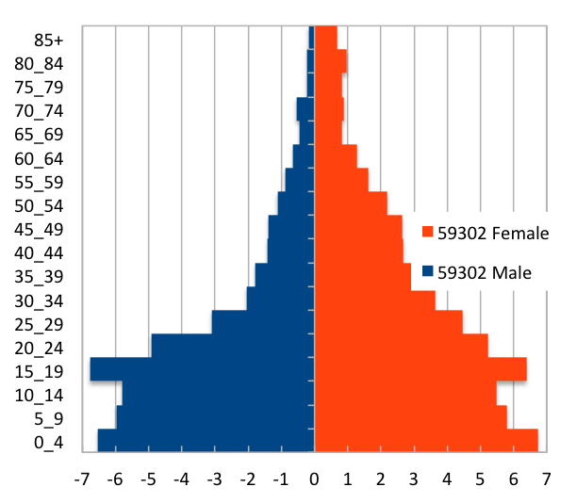

*Source: Statistics South Africa, Census 2011 small areas and population database*

The age and gender breakdown of the livelihood zone is given in **Figure 3**. It is important to note the low proportions of adult men in the livelihood zone as well as the high proportion of children (younger than 20). This unbalanced gender and dependency ratio is a consequence of apartheid, as most of the zone was a part of the former *bantustans*, supplying labour to urban, industrial and mining areas. The persistence of this pattern leads to shortages in the zone of human capital, which has impacts on productivity.

|  |
| --- |
| Seasonal Calendar |

Since this is a rural livelihood zone and rural life is determined by agricultural seasons, the information is organised by *consumption year*, which begins with the start of the main dry harvest and runs through to just before the next year's main dry harvest. In this zone, the main dry harvest begins in April, so the consumption year begins that month and runs up until the end of the following March. The livelihood strategies presented in this document apply to a particular year, one that is neither very good nor bad but is 'typical', or occurs frequently. This is called the *reference year* and the year chosen by participants was 2013-2014, or April 2013 to March 2014.

Figure 4: Seasonal calendar

|  |  |  |  |  |  |  |  |  |  |  |  |  |
| --- | --- | --- | --- | --- | --- | --- | --- | --- | --- | --- | --- | --- |
| **Activity** | Apr | May | Jun | Jul | Aug | Sep | Oct | Nov | Dec | Jan | Feb | Mar |
| Land preparation |  |  |  |  |  |  |  |  |  |  |  |  |
| Ploughing & planting (maize/sweet potatoes/groundnuts) |  |  |  |  |  |  |  |  |  |  |  |  |
| Green harvest/consumption |  |  |  |  |  |  |  |  |  |  |  |  |
| Weeding (maize/sweet potatoes) |  |  |  |  |  |  |  |  |  |  |  |  |
| Weeding (groundnuts) |  |  |  |  |  |  |  |  |  |  |  |  |
| Dry Harvest and threshing (maize/sweet potatoes) |  |  |  |  |  |  |  |  |  |  |  |  |
| Harvesting (groundnuts) |  |  |  |  |  |  |  |  |  |  |  |  |
| Wild foods & hunting |  |  |  |  |  |  |  |  |  |  |  |  |
| Morula brewing |  |  |  |  |  |  |  |  |  |  |  |  |
| Livestock sales |  |  |  |  |  |  |  |  |  |  |  |  |
| Purchases |  |  |  |  |  |  |  |  |  |  |  |  |

The main season for farming begins with land preparation in spring, followed by ploughing and planting, depending on the timing of the rains. Weeding (a period of intense activity and one in which work opportunities increase) takes place from December to April, with the dry harvest (another period for employment) beginning in April. The two main crops grown during this period are maize and groundnuts.

Wild foods are collected in all but a few months, while marula fruit are harvested and brewed from January to March.

|  |
| --- |
| Wealth Breakdown |

Wealth in this livelihood zone is determined primarily by three factors:

1. Employment, a product education and good social connections;
2. Ownership of a business, such as a spaza shop or bakkie, taxi;
3. Land holding; and
4. 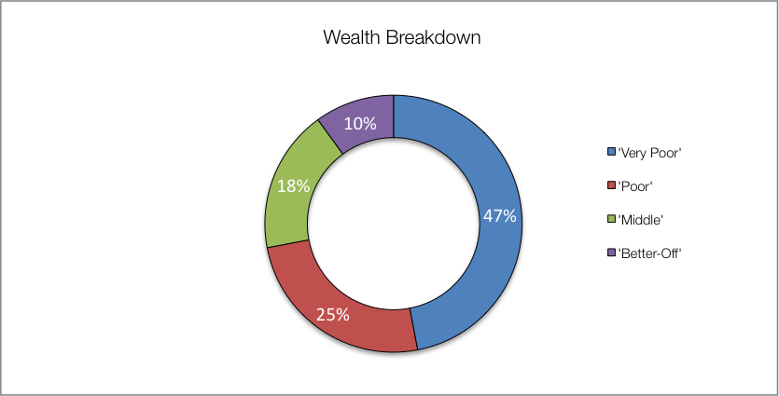Livestock, especially cattle.

The wealthiest households, described as the 'better-off', are those with permanent work and a salary of around R12,000 per month. Households that have lower-paying or less permanent work, which when averaged over the year is approximately R5,500 per month, are referred to as the 'middle'. Those who depend primarily on grants are described as the 'poor' and 'very poor'; collectively, they are about 72% of households. The 'very poor' and 'poor' supplement their grant income from casual labour and other sources.

Figure 5: Wealth breakdown in the lowveld open access irrigated cropping livelihood zone

|  |  |  |  |  |  |
| --- | --- | --- | --- | --- | --- |
| Category | Item | Wealth Group (typical value in brackets) | | | |
| 'Very poor' | 'Poor' | 'Middle' | 'Better off' |
| Hh Size |  | 5-10 (8) | 5-9 (7) | 4-9 (7) | 4-7 (6) |
| Land (Ha) | Owned | 0.05-1 (¾) | ¼-2 (1) | 1-2 (1.2) | 1-3 (2) |
| Cultivated | 0-1 (¼) | ½-2 (1) | ½-2 (1) | 1-3 (2) |
| Livestock (head) | Cattle | 0 | 0-4 (2) | 0-15 (10) | 5-60 (30) |
| Goats | 0 | 0-5 (3) | 5-13 (6) | 6-20 (10) |
| Income | Main | Grants | Grants | Formal employ | Formal employ |
| Annual (R) | 37,700 | 70,500 | 96,600 | 348,200 |

Source: Survey output, 2015

Since farming in this zone is important and by its nature taking proper advantage of irrigation requires resources and capital, the amounts of land owned and cultivated vary with wealth. 'Better off' households are thus able to develop more land and cultivate farms that are eight times larger than those of 'very poor' households.

In interviews key informants in the villages tended to provide larger household sizes, so field teams recorded values in excess to those reported in other surveys, especially the census. Except for single-people, the greatest number of people reside in a household of four people, which is also the most frequently occurring household size. This is less than the reported household size of six to eight, which is used in the ensuing sources of food and income—these can be scaled to the appropriate household size from the census.

|  |
| --- |
| Sources of Food |

Despite the irrigation projects and crop farming, purchases still make up the largest portion of people's sources of food. Food purchases contribute 60% to 80% of food energy needs; this is lower than in other livelihood zones in the province (which are 80% to 100%) but is still more than half of requirements. The contribution to food energy from staple food purchase *decreases* steadily from 57% for the 'very poor' to 20% for the 'middle', but then increases again to 47% for the 'better off'. The reason 'better off' households purchase more staple is that they prefer to sell their unmilled own-produced grain rather than eating it, and then purchase milled 'mealie meal' for consumption. This loses money but they are able to afford it.

Conversely, the contribution to food energy from non-staple food purchases *increases* from 11% of energy requirements for the 'very poor' to around 35% for the 'middle' and 'better off'.

Households and all wealth groups also consume food from their own crop production; the contribution from staples rises significantly from 10% for the 'very poor', to 44% for the middle. 'Better off' households consume less of their own-produced staple, 16%. Own produced non-staples—primarily groundnuts and vegetables (including green maize)—contribute an even amount to household food energy requirements, around 11% to 14%. However, the greater portion of this for 'very poor' households is green maize, which reduces the production of their dry harvest and their food diversity.

Figure 6: Sources of food (expressed as percentage of minimum average food energy needs) for each wealth group

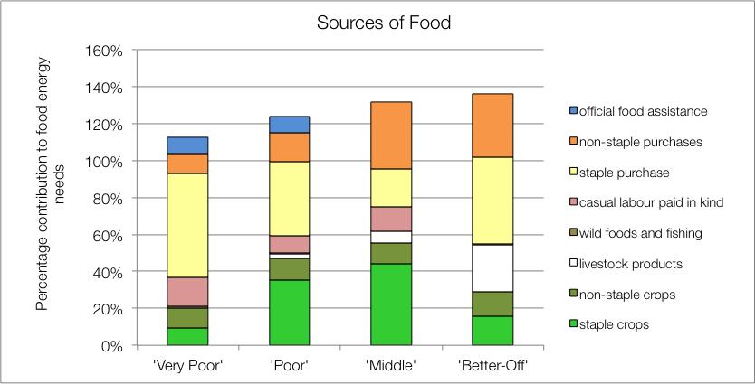

The 'poor', 'middle' and 'better off' households obtain food from their livestock; this is from occasional slaughter for meat and, for the 'middle' and 'better off', from cow's milk as well. Dairy production in this zone is not commensurate with herd sizes and livestock ownership. In general, a fraction of lactating cows (about one out of every three) are actually milked for consumption.

The poorest households' children receive additional food from school lunches, which is included as 'official food assistance'. Wealthier households tend to send their children to fee-paying schools that do not offer any kind of meals.

|  |
| --- |
| Sources of Cash Income |

Cash incomes vary considerably across wealth groups, with the 'better off' earning R348,200 per annum, more than nine times as much as the 'very poor', who earn only R37,700 per annum. **Figure 7** shows this distribution—it must be noted that the bars in the figure are not quartiles, they represent wealth groups and wealth groups are *not* distributed evenly (see **Wealth Breakdown**, above).

Figure 7: Sources of annual cash income by wealth group

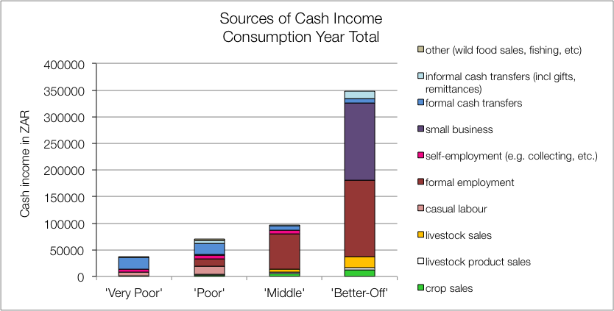

The main sources of cash income for in the zone are: small business—for the 'better off'—formal employment—for the 'middle' and 'better off'—and cash grants—for the 'poor' and 'very poor'. This is in keeping with most surveys that ask for the main livelihood source.

However, the point of this enquiry was to gain understanding of how *all* livelihood sources come together to make up an income. This is essential because it enables practitioners to link a hazard (such as a price change) to outcomes and it enables other users to see potential areas of intervention. By dividing the value of each source by the total income, we can see these proportions and this is presented in the graph in **Figure 8**.

Figure 8: Sources of annual cash income as a percentage of total, by wealth group

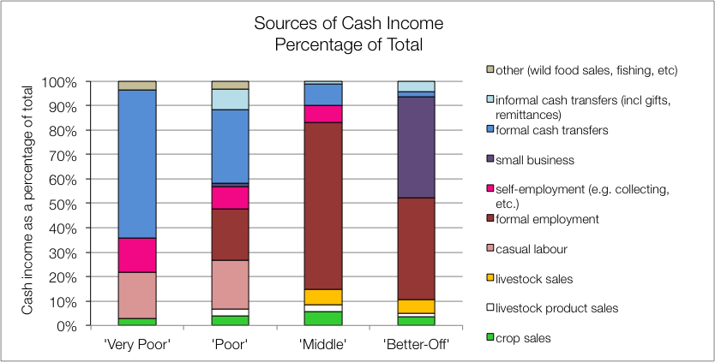

For the 'very poor' and 'poor', grants make up 61% and 31% of total cash income, respectively; the remainder comes from casual labour (mostly domestic work, agricultural piece work, construction jobs), self-employment (collecting natural products for sale, weaving, making bricks, etc.), and informal cash transfers (usually remittances). Small amounts of income are earned through sale of wild foods (such as mopane) and sale of animal products (usually meat or eggs).

The 'middle' and 'better off' gain their wealth from a formal wage or salary for the better part of their income. Some 'middle' households may have a member that works seasonally on the commercial farms but earnings typically amount to almost R66,000 per annum, while the 'better off', who may have more permanent work, earn around R100,000 to R300,000 per annum (median R144,000). Households with established businesses also tend to be 'better-off', as these businesses bring in around R100,000 to R300,000 per annum as well (median R144,000), similar to fixed employment. 'Middle' and 'better off' households also gain cash from crop and livestock sales, highlighting potential for farming as proper livelihood, although their earnings are far short of their income expectations. The 'middle' and 'better off' also benefit from grants (for example, the old age and fostering grants are not means-tested and the probability of a household having a pensioner in it is about one in two—see the population pyramid under **Zone Description**).

The numbers of cows that are actually milked compared with those likely to be lactating, is low. This is due to a number of factors: lack of economic incentives for milking, lack of time by the cattle-owners (because they are full-time employed) and minimal herd management.

|  |
| --- |
| Hazards, Vulnerabilities and Response Strategies |

Since households are dependent on markets for most of their food, households are most vulnerable to market-related shocks. These 'market shocks' may consist of: escalating food prices, eroded grants (for example, when they are not adjusted to match consumer inflation) and job losses.

Drought may have an impact, as it will reduce crop production and affect this source of food and income. However, unless food prices also rise simultaneously, households will manage crop losses by prioritising more cash to food purchases.

Additional response strategies households may engage in under stress are: switching expenditure, seeking more casual work (usually outside of the village) or selling off assets or belongings.

|  |
| --- |
| Household Hunger Score |

The majority of the households (70 percent) experience no to little hunger and two per cent of households had severe hunger in this livelihood zone. Only 28 per cent of the households reported a moderate hunger situation – see **Table II**.

Table II - Household Hunger scale indicator

|  |  |  |  |  |  |
| --- | --- | --- | --- | --- | --- |
| No to Little Hunger | | Moderate Hunger | | Severe Hunger | |
| Count | Percent | Count | Percent | Count | Percent |
| 75 | 70 | 30 | 28 | 2 | 2 |

Source: Survey Output 2015

|  |
| --- |
| Dietary Diversity and Food Consumption Score |

The largest number, 40 percent of sampled households, have medium dietary diversity scores indicating that they consume four to five food groups during the day before the survey. 29 Percent of households have the highest dietary diversity (at least six food groups) and there are 31 percent of households with the lowest dietary diversity indicating that they consume three or fewer food groups.

Figure 9: Dietary Diversity Scores

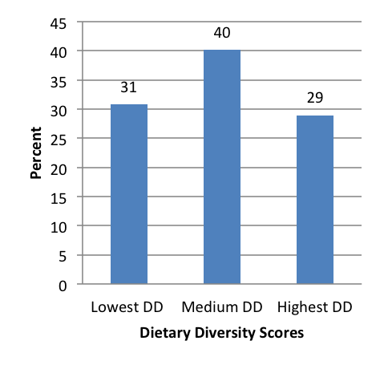

Figure 10: Food consumption scores

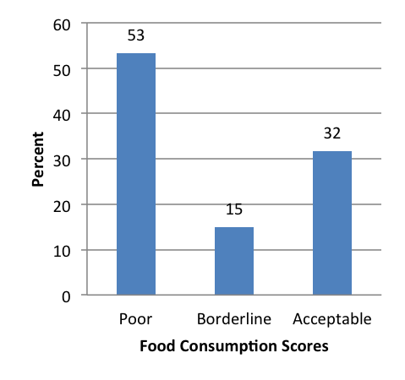

The majority of households – 53 percent – were consuming poor diets. While 20 percent of the households were within an acceptable consumption pattern, 15 percent of the households were within borderline consumption pattern.

|  |
| --- |
| Nutrition and Anthropometry |

Acute malnutrition is predominant in the 36-47 months old children in the livelihood zone (Figure 11). About nine percent and two per cent of under-five children were moderately and severely malnourished, respectively in the livelihood zone. The missing of figures in the other age group categories were not picked up in the sample of the livelihood zone.

Figure 11: Prevalence of severe and moderate acute malnutrition by age grouping

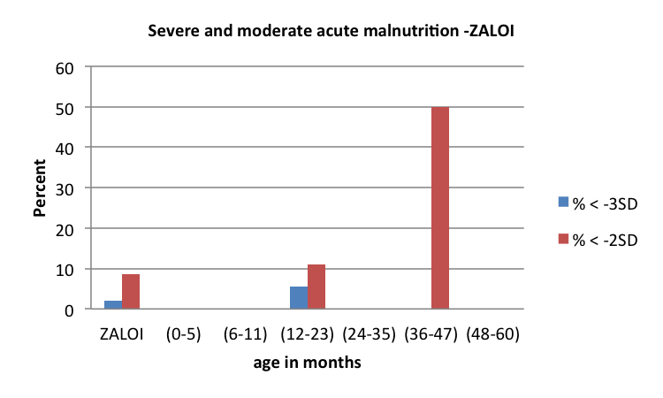

The prevalence of severe and moderate stunting is 27 per cent and 11 per cent, respectively in the livelihood zone (Figure 12). There is a high prevalence of severe and moderate stunting among under-five children within 48 to 60 months of age seconded by children who are 24 to 35 months old. The trend of moderate and severe stunting is increasing as under-five children increase their ages from 12 months to 60 months. The results also indicate that there were no moderately and severely stunted under-five children with 0 months to 11 months in the livelihood zone.

Figure 12: Prevalence of severe and moderate stunting by age grouping

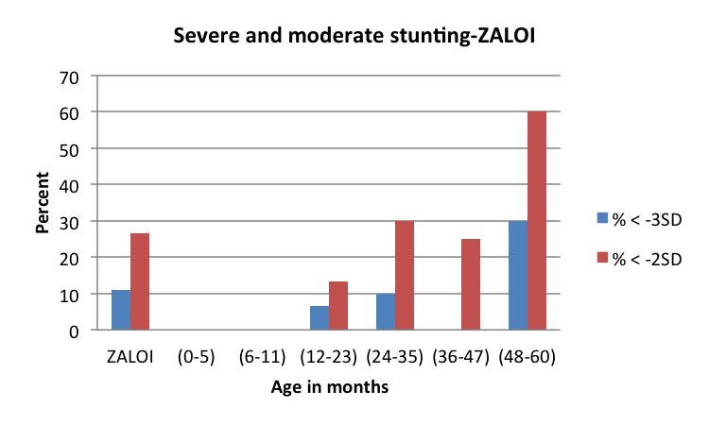

The prevalence of moderate underweight was six per cent in the livelihood zone (Figure 13). There is a high prevalence of moderate underweight (25%) among under-five children within 36 to 47 months of age seconded by children who are within age categories of 24 to 35 months and 24 to 35 months old. The results indicate that there is a zero prevalence of severe underweight in the livelihood zone. The results also indicate that there were no moderately and severely underweight under-five children with 0 months to 23 months in the livelihood zone.

Figure 13: Prevalence of severe and moderate underweight by age grouping

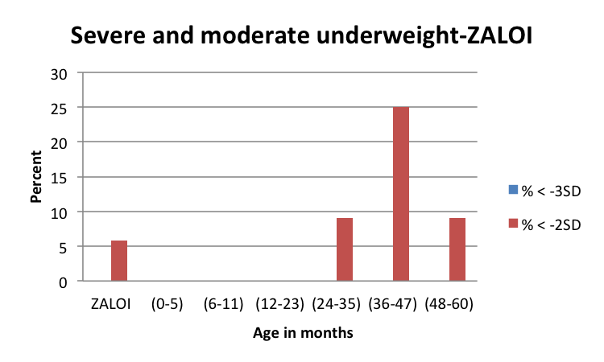

|  |
| --- |
| Conclusions and Recommendations |

As already mentioned, food and cash income from livestock products is low for the numbers of animals present. To increase production, herds would need more and better management, an investment that would need to be justified through better returns. These returns could be increased by, for example, support to dairy marketing and greater provision of services and infrastructure to encourage production. Crop farming yields could also be improved through greater service provision and market support, though crops are constrained by environmental factors. This increased productivity will unlikely benefit all but a few households directly, but will create additional new possibilities through increased work opportunities. For many 'poor' and 'very poor' households, grants will remain the main source of income for some time to come.